BOSTON UNIVERSITY

COLLEGE OF ENGINEERING

ME306 INTRODUCTION TO MATERIALS SCIENCE

**LAB No. 2 X-Ray Diffraction**

[Version Spring 2014]

I. Introduction

The purpose of this lab is to introduce you to x-ray diffraction methods and the information that can be derived from the resulting data.

II. X-Ray Diffraction (XRD) Theory

A beam of X-Rays can be created with a single wavelength on the same order of magnitude as the spacing between the planes of atoms in a crystal. The regular repetition of identical groups of atoms throughout a crystal forms a three-dimensional grating which diffracts this beam of X-Rays in much the same way that an optical grating diffracts a light beam. The diffracted X-Rays show a characteristic finger print of the specific crystal structure. Amorphous substances lack the long range order required for constructive interference so they have a diffraction pattern similar to what we'd expect for a liquid. For crystals, the X-Ray pictures can help in determining space lattices, space groups and positions of atoms in the unit cell. Diffraction also indicates the orientation of a single crystal and the preferred orientation in a polycrystalline specimen; the dimensions of the unit cell to a high degree of precision; qualitative and in some instances, quantitative measurements of residual and applied stress; information concerning the effect on the lattice of plastic deformation, of the mechanism of deposition, crystallization, transformation, age hardening and precipitation and the constitution of organic and inorganic systems, minerals and alloy systems.

X-Ray Production

A tungsten filament is heated to produce electrons which are then accelerated by a high voltage (typically 35-40 KeV) to strike a copper target. The electrons are energetic enough to knock out core energy level electrons from the copper, higher energy level electrons will move to fill those lower energy positions and the energy difference between the electron levels is released in the form of electromagnetic radiation. In this case copper produces three characteristic X-Rays: Kα1 with a wavelength of 1.540 angstroms from n=2 P3/2 spin electrons moving down to n=1 level; Kα2 X-Rays at 1.544 angstroms from n=2 P1/2 spin electrons moving down to n=1 level; K with a wavelength of 1.392 from n=3 electrons moving down to n=2 level. These are referred to as Cu Kα1, Cu Kα2, and Cu K radiation. The X-Rays produced are then focused into a beam to strike the sample.

Figure 1 illustrates the X-Ray source incident at Bragg angle θ striking the sample at center. The sample can be a powder or a solid and is fitted into the stage such that it is centered, level with the stage, and cannot fall out as it moves from 0° to 90° 2θ. Often double sided tape may be used, or for powder a plastic plate with concentric ridges. The X-Ray equipment also has slots for slits and filters. Slits narrow the beam and filters absorb specific wavelengths, for example a Ni filter may be used to absorb Cu K radiation because its K absorption edge is 1.488 Angstrom so it absorbs the K much more strongly than the Kα radiation. Without the filter you would see up to three peaks for each constructively interfering planes due to the three different incident wavelengths, each peak would be referred to by its designation Cu Kα1, Cu Kα2, or Cu K. A scan is typically run with the Ni filter in place and the Kα2 peak only becomes visible at large scattering angles where it differs more from the Kα1 peak.

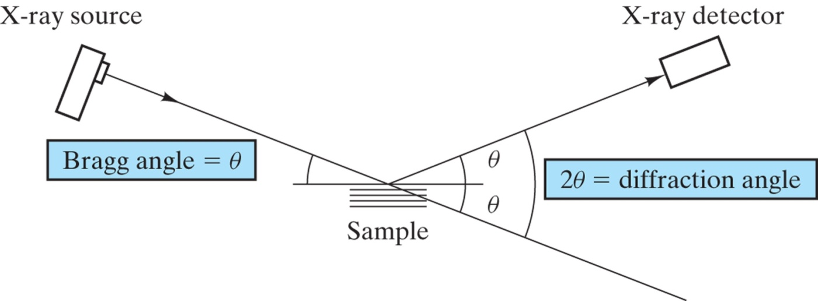

Figure 1. Illustration depicting incident Bragg angle θ and measured diffraction angle 2θ

Derivation of Bragg's Law

The underlying principle for all XRD applications is the same – Bragg’s Law. Given a parallel set of planes of atoms repeating throughout a crystal and spaced at intervals of d, the condition for X-Ray reflection from these planes is, n·λ = 2·d·sinθ where λ is the wavelength of the X-Rays measured in the same units as d, n is the order of the reflection and θ is the angle of incidence of the beam on the planes, which is equal to the angle of reflection from the planes. Figure 2 simplifies the scenario by depicting the atoms as a plane instead of individually and the incident waves as straight lines. Observe that the second incident X-ray has a longer path length than the first by 2x, this causes a phase shift between the two diffracted waves. Note the diffracted beams must be in phase to create constructive interference.

From trigonometry we know that therefore  Equation 1

We observed the path difference Δ = 2x Equation 2

For constructive interference Δ must be an integer multiple of the wavelength:

Δ = nλ Equation 3

Combining equations 1-3 we have Bragg's Law:  Equation 4

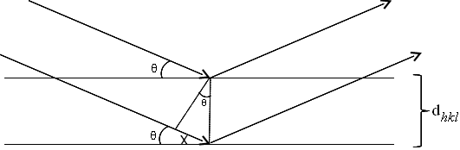Figure 2. Drawing for derivation of Bragg's Law

Diffraction angle 2θ

Figure 3. Diffraction pattern for polycrystalline α-iron (BCC)

Table 1 shows the reflection rules for X-Ray diffraction for common structures. These rules aid in identifying which crystal structure is producing the diffraction pattern.

|  |  |  |
| --- | --- | --- |
| **Crystal Structure** | **Diffraction Occurs When:** | **Diffraction Does Not Occur When:** |
| Simple Cubic (SC) | All | None |
| Body-Centered Cubic (BCC) | *h* + *k* + *l* = even | *h* + *k* + *l* = odd |
| Face-Centered Cubic (FCC) | *h*, *k*, *l* unmixed (i.e. all even or all odd numbers) | *h*, *k*, *l* mixed (i.e. both even and odd numbers) |
| Hexagonal Close Packed (HCP) | For even *l: h* + *2*k = 3m  OR  For either even or odd *l:*  *h* + 2*k* = 3m +/- 1  m is an integer | *h* + 2*k* = 3m, *l* is odd  m is an integer |

Table 1: Reflection Rules of X-Ray diffraction for common structures

The diffraction rules are derived from the calculation of the structure factor, *F*, for each crystal structure assuming a perfect monoatomic crystal. The structure factor describes how the atom locations affect the scattered beams intensity. Equation 2 shows the general form of the structure factor equation. Let's prove these rules for the BCC crystal structure. To compute the total structure factor for a crystal structure we must sum the factor for each atom in the unit cell.

$F_{hkl}= \sum_{1}^{N}{f_{n}}e^{2πi(hu_{n}+kv_{n}+lw_{n})}$ Equation 2

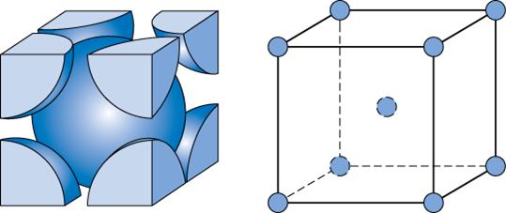

Figure 3. BCC Unit Cell

The BCC structure, Figure 3, has 2 atoms at each corner (0,0,0) and at the center of each face (1/2,1/2, 1/2) these positions correspond to the *uvw* of each atom. *Fhkl* is a complex number representing the amplitude and phase of the resultant wave. The absolute value, or |*F*|, gives the ratio of amplitudes of the wave scattered by all atoms of a unit cell to the amplitude of the wave scattered by one electron. The intensity of the beam diffracted according to Bragg’s law is proportional to |*F*|2. Therefore if we calculate the structure factor we determine if the location of the atoms allows a constructive diffracted beam for each *hkl*.

$$F=fe^{2πi(0)}+fe^{2πi\left(\frac{h}{2}+\frac{k}{2}+\frac{l}{2}\right)}=f[1+e^{πi(h+k+l)}$$

When (*h+k+l*) is even: $F=2f$

$F^{2}=4f^{2}$

When (*h+k+l*) is odd: $F=0$

$F^{2}=0$

So you can see when (*h+k+l*) is even you have resultant x-ray diffraction.